**Scenarios**

Scenario 1: Deposit to Chequings

* + Client opens system
  + Client enters ‘a’ to log in
  + Client enters ID 1003
  + Client enters PIN 2222
  + Client checks balance of all accounts
  + Client selects deposit (option ‘a’)
  + Client selects chequings account (option ‘a’)
  + Client enters 100 as amount to deposit
  + System opens chequings account
  + System adds $100 to account
  + System returns user to overview menu
  + Client checks new balance
  + Client logs off (option ‘g’)
  + Client exits system (option ‘e’)

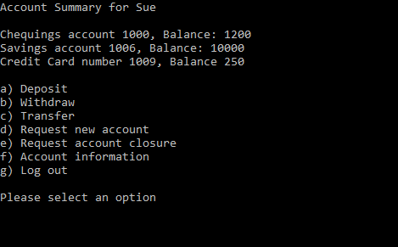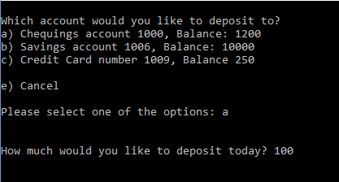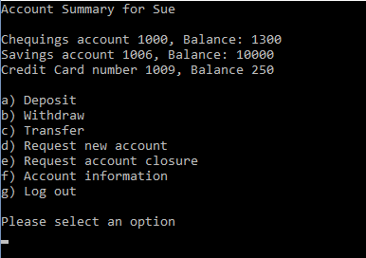

Scenario 2: Transfer to Credit Card (Pay Credit Card)

* Client opens system
* Client selects login option (option ‘a’)
* Client enters ID 1003
* Client enters PIN 2222
* Client checks balance of all accounts
* Client selects transfer (option ‘c’)
* Client selects chequings account (option ‘a’)
* Client selects credit card account (option ‘c’)
* Client enters 250 as amount to pay
* System opens chequings account
* System opens credit card account
* System subtracts $250 from chequings
* System subtracts $250 from Credit Card (subtract since client is paying off credit)
* System returns user to overview menu
* Client checks balance of both accounts
* Client logs off
* Client exits system

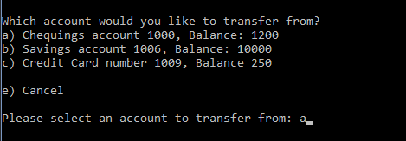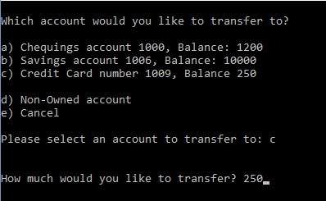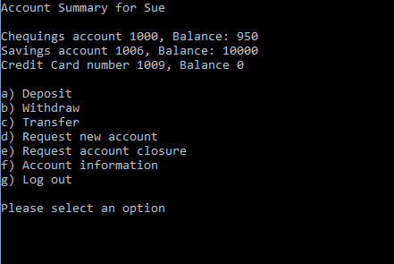

Scenario 3: Add New User

* Client opens system
* Client selects login option (option ‘a’)
* Client enters ID 1000
* Client enters PIN 1234
* Client selects Add New User (option ‘e’)
* Client enters name “Bill”
* Client enters PIN 5345
* Client enters SSN 900811711
* Client selects Customer as type (option ‘1’)
* Client confirms creation of new user (option ‘a’)
* System creates new user
* System adds user
* System confirms the addition to client
* System returns client to menu
* Client views all users in system (option ‘a’)
* Client returns to main menu
* Client logs out
* Client exits system

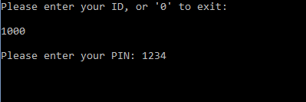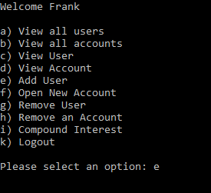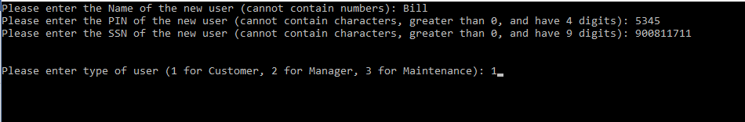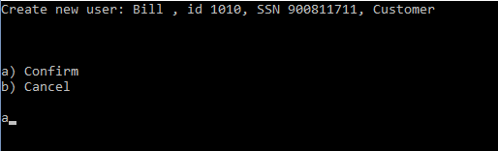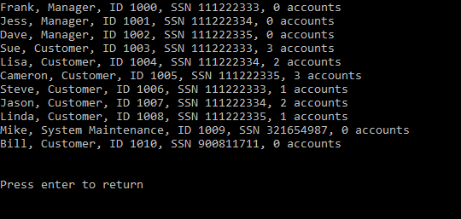

Scenario 4: View User Accounts

* Client opens system
* Client selects login option (option ‘a’)
* Client enters ID 1000
* Client enters PIN 1234
* Client selects View User (option ‘c’)
* Client enters ID 1003
* System searches for User with ID 1003 and returns it
* System displays user and account information
* Client returns to main menu
* Client logs out
* Client exits system



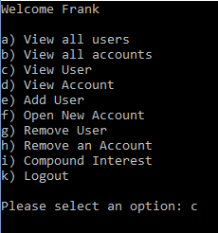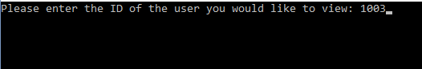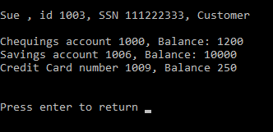

Scenario 5: Turn System Trace Off

* Client opens system
* Client selects login option (option ‘a’)
* Client enters ID 1009
* Client enters PIN 1212
* Client turns off System Trace (option ‘b’)
* System turns trace off
* System displays success
* User returns to main menu
* User logs out
* User exits system

